**[Troubleshooting an access issue with a custom master page](https://sharepoint.rackspace.com/learning/articles/Pages/SharePoint-2013--troubleshooting-an-access-issue-with-a-custom-master-page.aspx)**

There are several reasons create a custom master page, whether it be to remove features users can see or add custom text.  Whatever your reason, if you or your end users are now encountering the “Sorry you don’t have access to this page” message it could be because they don’t have access to the Master Page Gallery library.  To resolve this issue please follow the steps below:  
  
1. On the home page of your site click the Site Settings **gear**.  
  
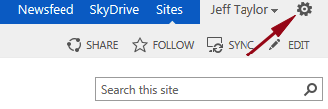  
  
2. From the drop-down select **Site settings**.

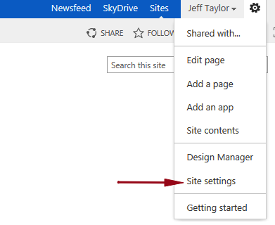

3. On the Site Settings page, under Web Designer Galleries, click **Master pages and page layouts**.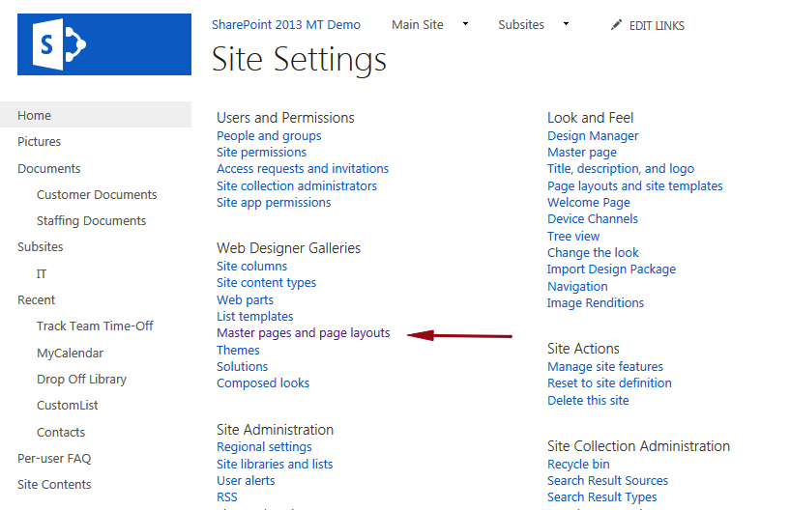

4. In the Master Page Gallery library click **Library**, to expand the ribbon.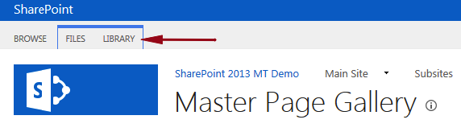

5. On the far right click **Library Settings**.

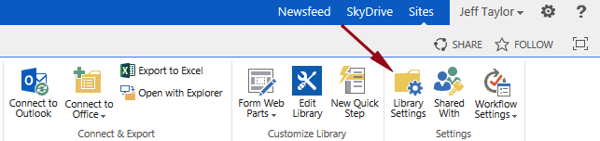

6. Under Permissions and Management click **Permissions for this document library**.

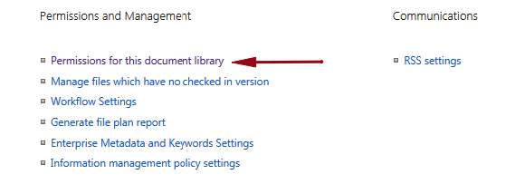

7. This will display all of the groups and or users who have access to view the master page.   
  
8. From the ribbon click **Grant Permissions**.

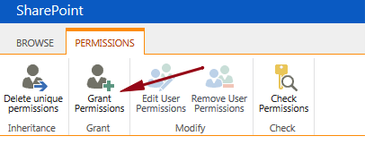

9. Enter the users individual names or a SharePoint group.  
  
10. Click **SHOW OPTIONS**.

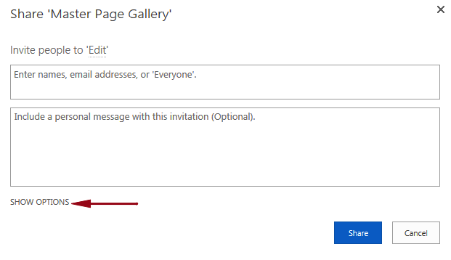

11. This will allow you to modify the user level of permission, if you would like.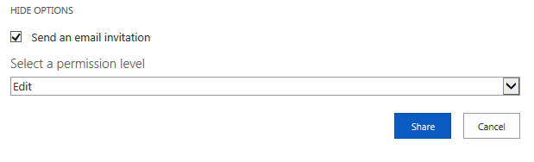

12. Once you have verified the users/groups and level of permission click **Share**.   
  
13. You will then see the users and or groups in the list.  
  
14. Log back into the site with one of the users who previously didn’t have access and verify this worked.  
  
Please understand if this does not resolve the issue you’re encountering there could be another underlying issue with permissions that still needs to be addressed.